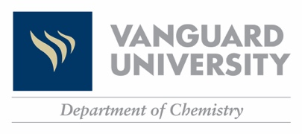
Which CHEMISTRY Course is right for me??

Biology, Chemistry, Biochemistry and Kinesiology Pre-Health majors’ goal should be enrollment into Chem 120/L.

Majors: Biology, Chemistry, Biochemistry, Kinesiology Pre-Health
Path 1: SAT Math score of 620+  Path 2: ACT Math test score of 27+  Path 3: AP Chemistry exam score of 3+  Path 4: SAT Chemistry subject test score of 700+ |  | Meets criteria |  | Enroll into  Chem 120/L
Does not meet criteria |  | Preparation Path 1: Complete Vanguard Chemistry Prep ALEKS to 100% Mastering  Course Code: AT6HH-XJJNT
 |  | Preparation Path 2: Pass Chem 112C/L with a C or better
Does not meet criteria |  | Preparation Path 3: Complete Nursing Prep ALEKS to 100% Mastering  Course Code: GY6HQ-JEUMJ
Path 1: SAT Math score of 580+  Path 2: ACT Math test score of 25+  Path 3: AP Chemistry exam score of 3+ |  |  |  | Enroll into  Chem 113/L  Course Code: U6FLU-MPAUV
 |  | Meets criteria
Majors: Nursing
The Nursing student’s goal should be enrollment into Chem 113/L.

To Enter a Placement Course:
- Go to www.aleks.com
- Click on New User? SIGN UP NOW!
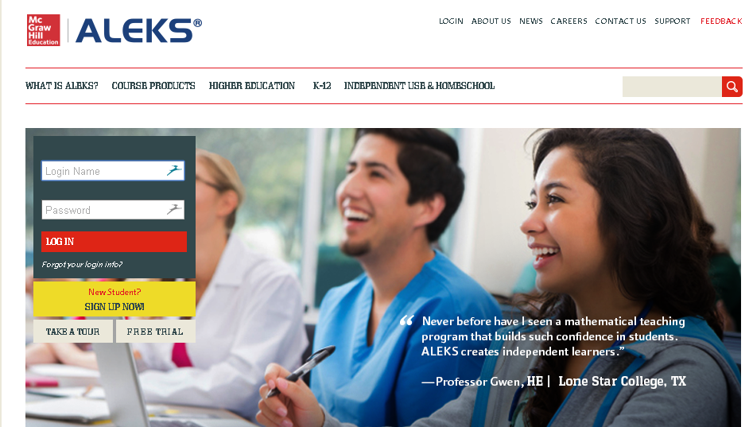

- Vanguard Chemistry Placement Exam (going to Chem 120)
  - Enter Course Code: AT6HH-XJJNT
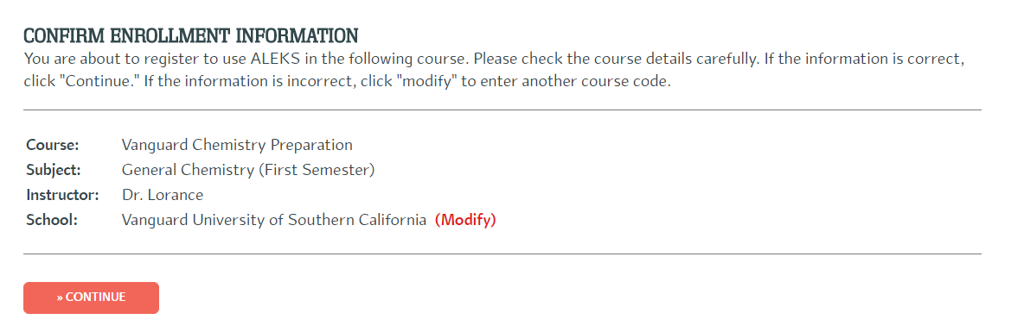

- Nursing Preparation Course (going to Chem 113)
  - Enter Course Code: GY6HQ-JEUMJ
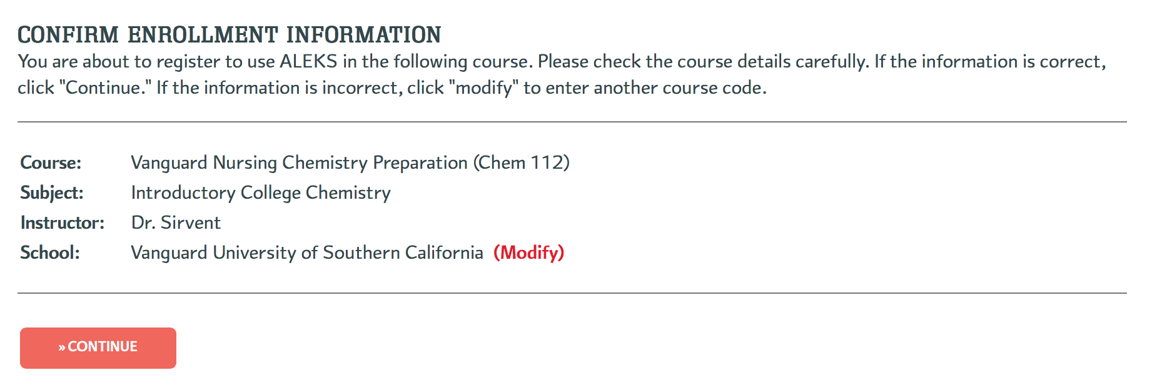
- Fill out student information webpage
- Take the Initial Knowledge Check
  - You will be asked to solve about 20-30 problems (this will take you anywhere from 30 to 90 minutes – at any time you can logout and log back on, it will keep your place).
  - You'll get no help at all, nor should you try to find any. The idea is to find out where you should start learning, and you want ALEKS to get that just right. If you get your friend the chem grad student to help you, or do a lot of googling, you'll just end up with learning that is way too hard and frustrating, because you'll be missing important pre-requisites. If you don't take the assessment seriously, you'll just end up wasting time on material you already know.
  - The assessment is over the entire first-year material, so you can expect to get problems you have no idea how to solve. Don't worry about that. This is a placement course, not a final exam. You're not going to be graded on it, and there's no reward for doing better or penalty for doing worse.
  - If you earn 100% immediately, you are able to register in the respective Chem 120/L or Chem 113/L. Otherwise you have 2 options: enroll in Chem 112 or complete the learning mode (described below).

- Learning Mode
  - After the assessment, you will see you ALEKS “pie.” This shows you what you already know, what you’re ready to learn, and what topics you’ll eventually need to learn, and by what dates.
  - You can begin working on topics by scrolling over your pie slices, available topics will be hyperlinked and you can begin!
  - Once you “fill the ALEKS pie” to 100%, you may enroll in the desired Vanguard course.

